**Lab 4: DHCP**

University of Windsor

Department of Electrical and Computer Engineering

ELEC 8560 – Computer Networks

Semester: Fall 2023

**Student Name**: Amey Mahendra Thakur

**Student number**: 110107589

**Answers:**

1. DHCP messages are transmitted over **UDP (User Datagram Protocol).**

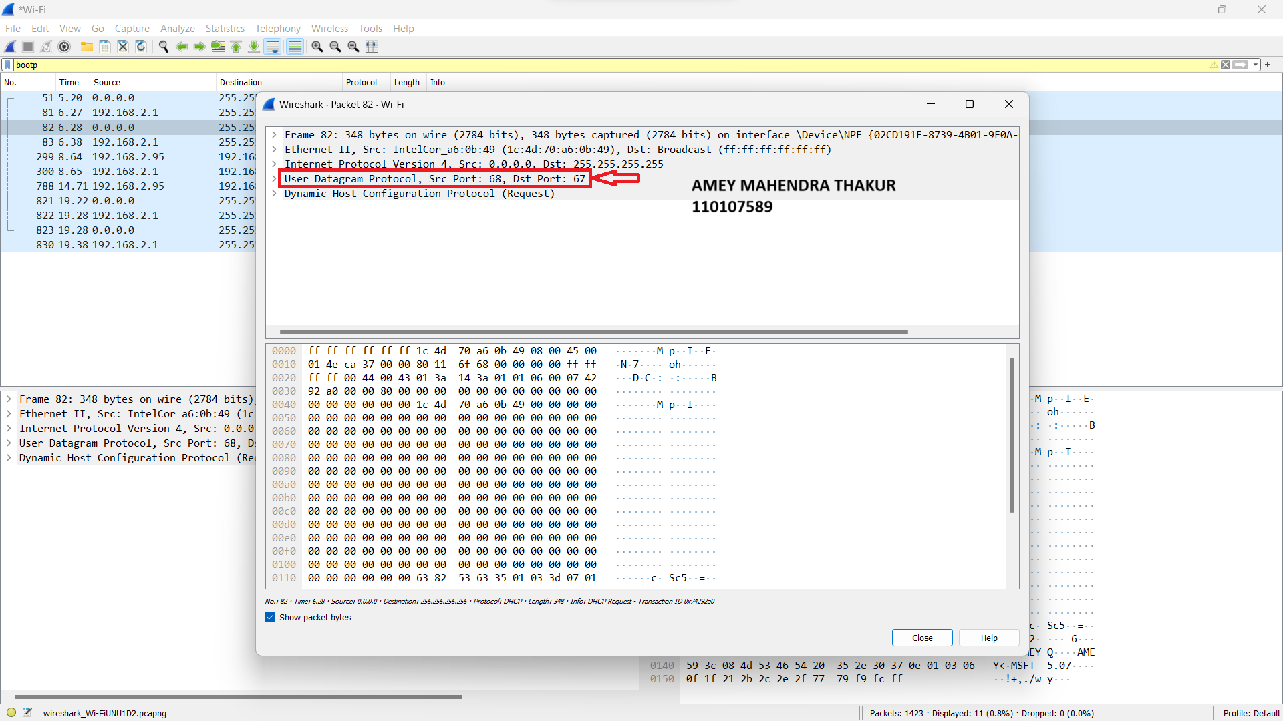

1. The port numbers align with the configuration specified in the lab assignment, with the **source port set to 68 and the destination port set to 67.**

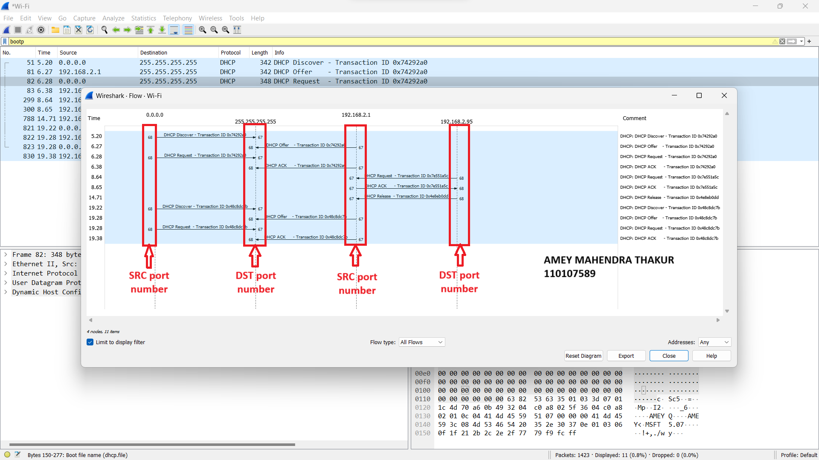

1. The link-layer address of my host is **(1c:4d:70:a6:0b:49).**

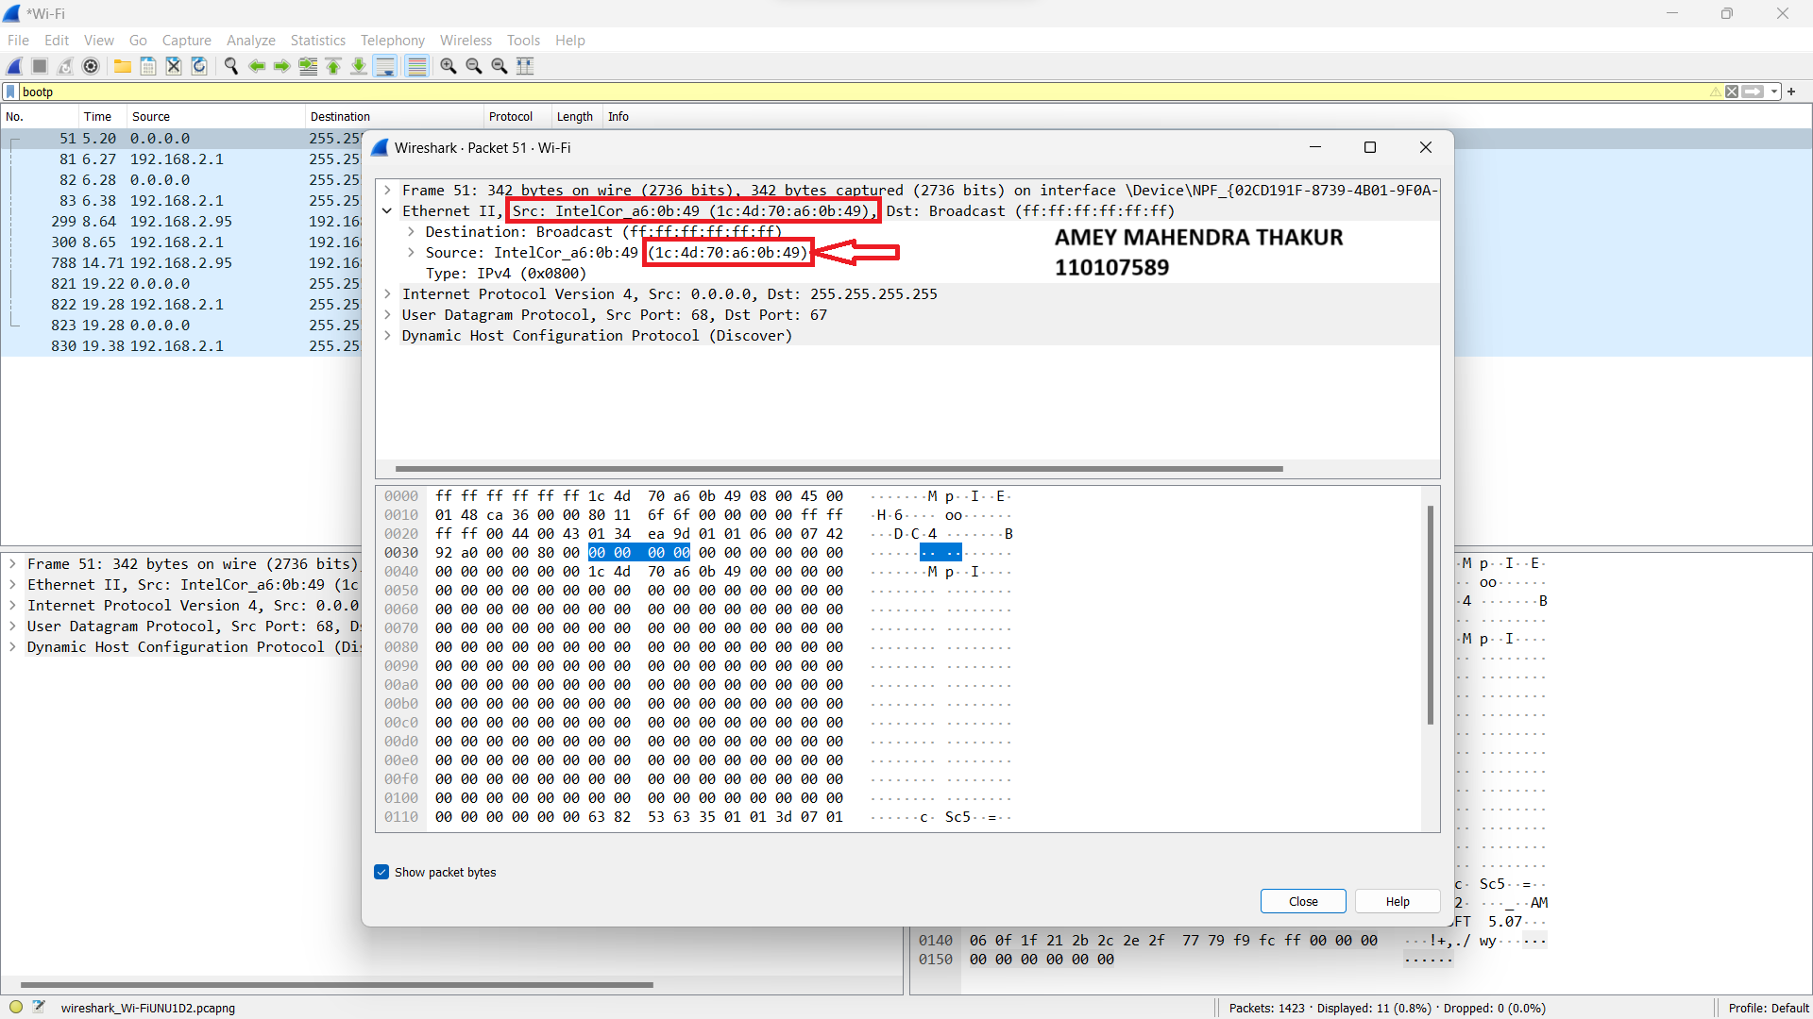

1. The DHCP discover message is distinguished from the DHCP request message by the value of **Option 53.**

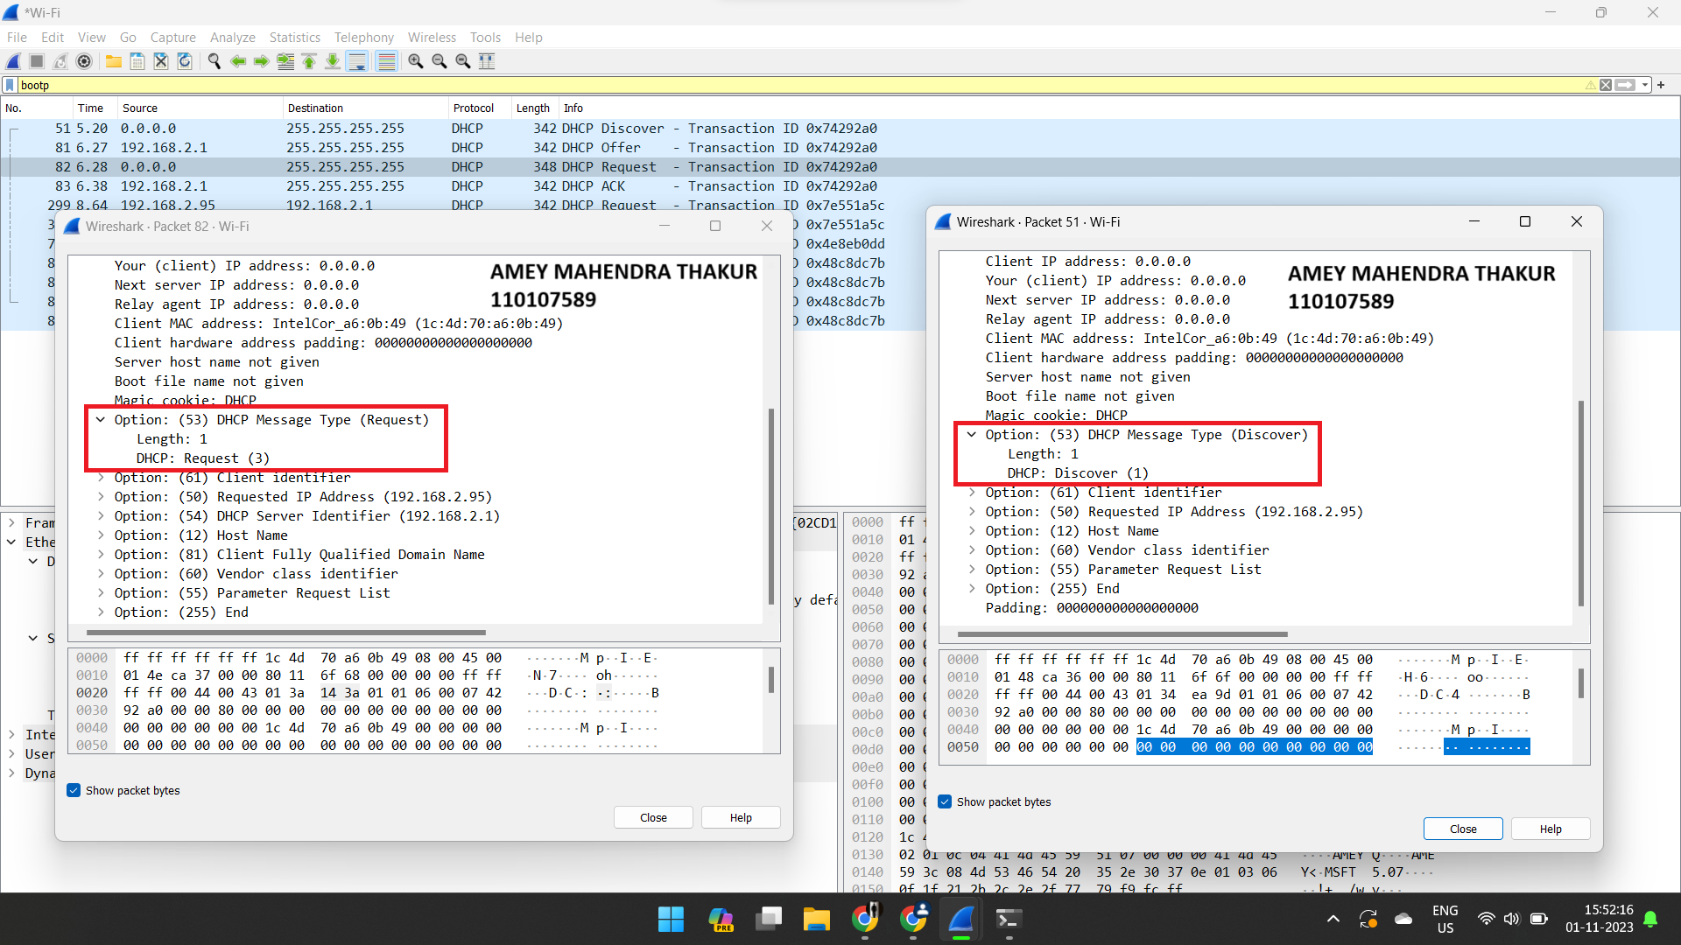

1. The values of the Transaction-ID in first and second set are:

First Set (Discover/Offer/Request/ACK):

* Discover: 0x74292a0
* Offer: 0x74292a0
* Request: 0x74292a0
* ACK: 0x74292a0

Second Set (Discover/Offer/Request/ACK):

* Discover: 0x48c8dc7b
* Offer: 0x48c8dc7b
* Request: 0x48c8dc7b
* ACK: 0x48c8dc7b

The purpose of the Transaction-ID is to differentiate between different DHCP transactions. Each set of Discover, Offer, Request, and ACK messages represents a separate DHCP transaction. By having a unique Transaction-ID for each transaction, the host can distinguish between them and ensure that the DHCP process is carried out correctly for each individual request made by the user. This helps prevent confusion and ensures that the DHCP server can respond accurately to each request.

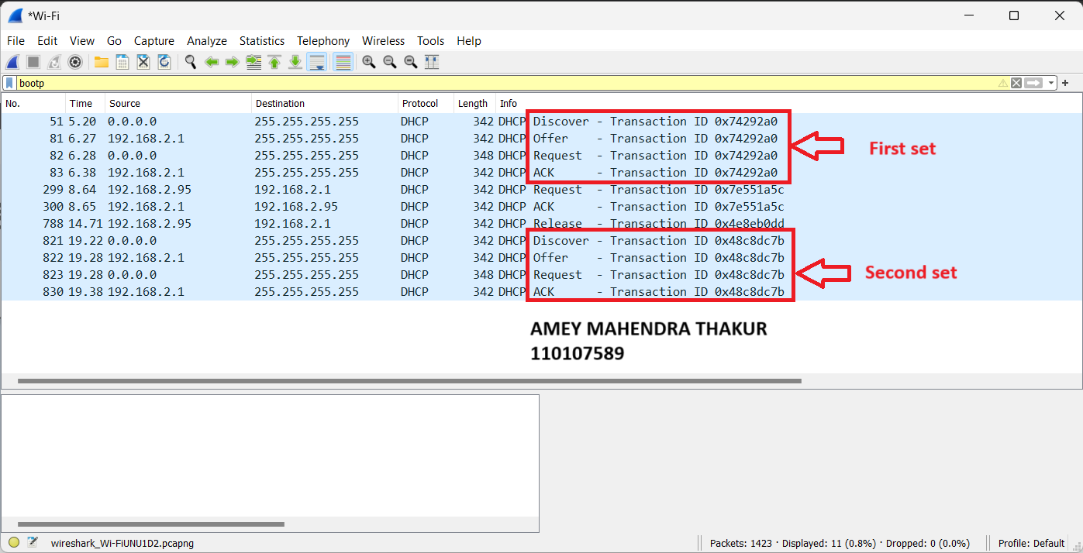

1. In a typical DHCP exchange, before the host is assigned a confirmed IP address, the following values are used in the encapsulating IP datagrams for each of the four DHCP messages:

Discover (Client to Server):

* Source IP Address: 0.0.0.0 (Unspecified)
* Destination IP Address: 255.255.255.255 (Broadcast)

Offer (Server to Client):

* Source IP Address: 192.168.2.1 (IP address of the DHCP server)
* Destination IP Address: 255.255.255.255 (Broadcast)

Request (Client to Server):

* Source IP Address: 0.0.0.0 (Unspecified)
* Destination IP Address: 255.255.255.255 (Broadcast)

ACK (Server to Client):

* Source IP Address: 192.168.2.1 (IP address of the DHCP server)
* Destination IP Address: 255.255.255.255 (Broadcast)

These values allow the DHCP exchange to take place even before the client has been assigned a specific IP address, as the client uses an unspecified source IP address (0.0.0.0) and broadcasts its messages to 255.255.255.255. The server, which has a known IP address (192.168.2.1 in this case), responds to these broadcast messages accordingly. Once the DHCP process is completed, the client will have a confirmed IP address assigned.

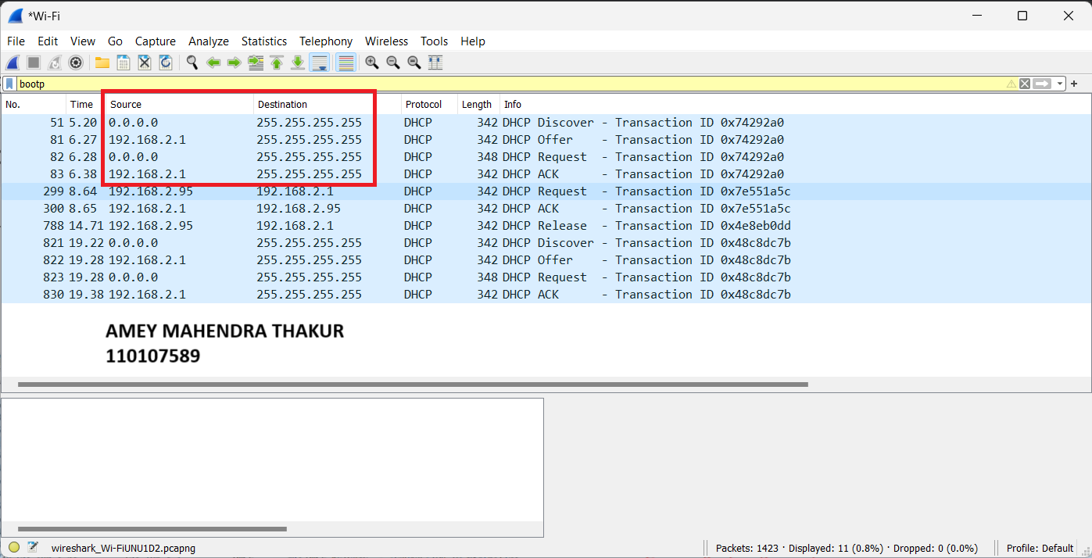

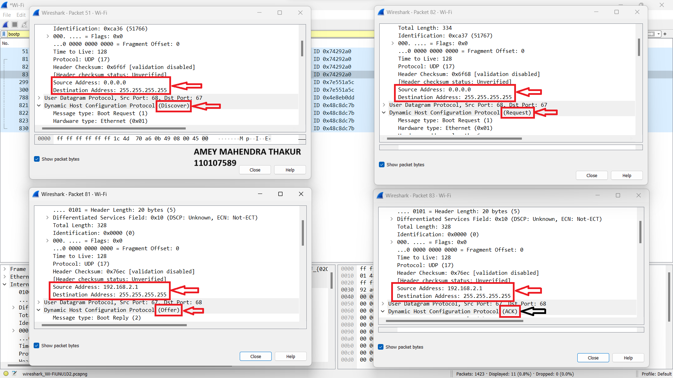

1. The IP address of my DHCP server is **192.168.2.1.**

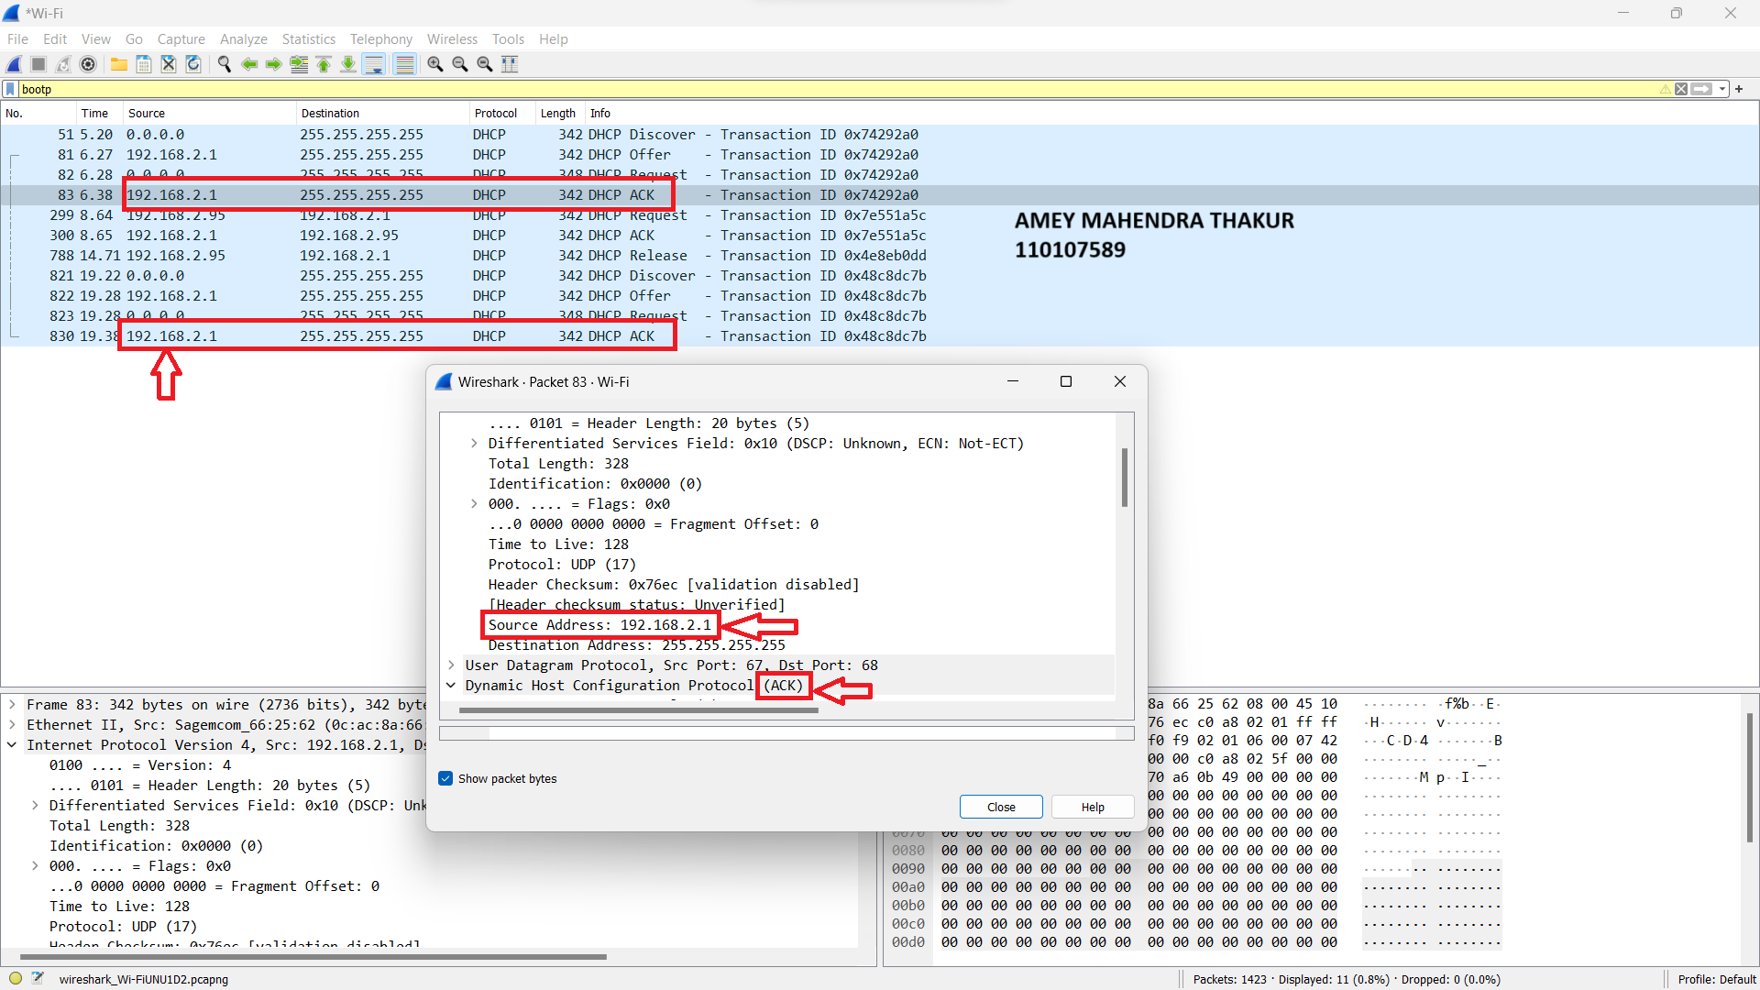

1. The DHCP server is offering the IP address 192.168.2.95 to my host in the DHCP Offer message. This information is conveyed in the Option 53 field, where the DHCP message type is specified as "Offer" (code 2).

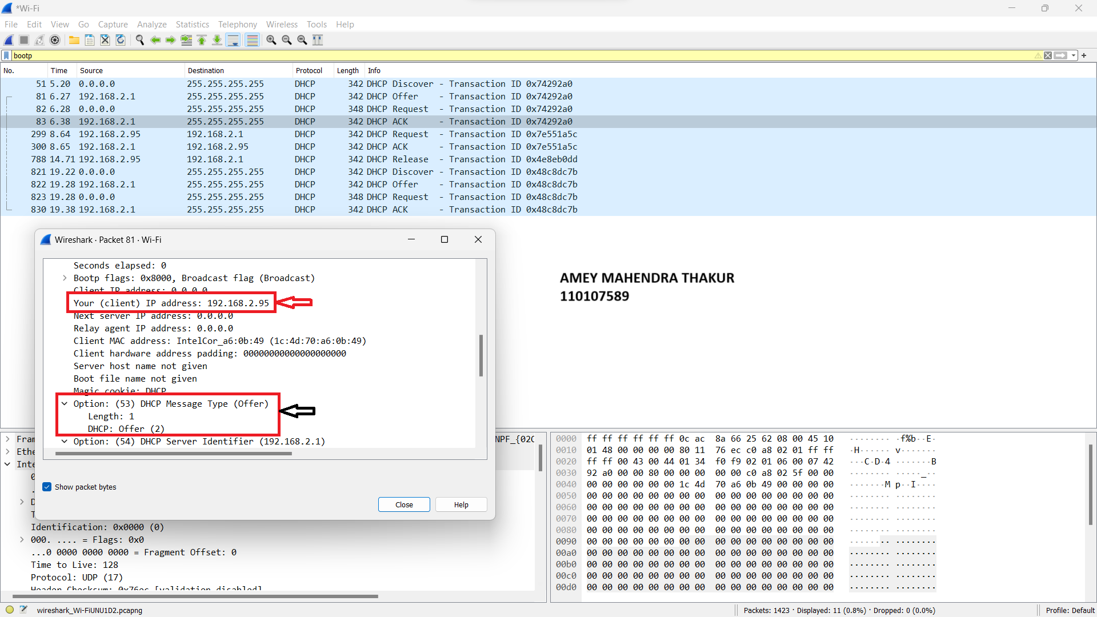

1. The "router" line within the DHCP Offer message informs the client about the address of its designated default gateway. Meanwhile, the "subnet mask" line conveys to the client the specific subnet mask it should employ for network configuration.

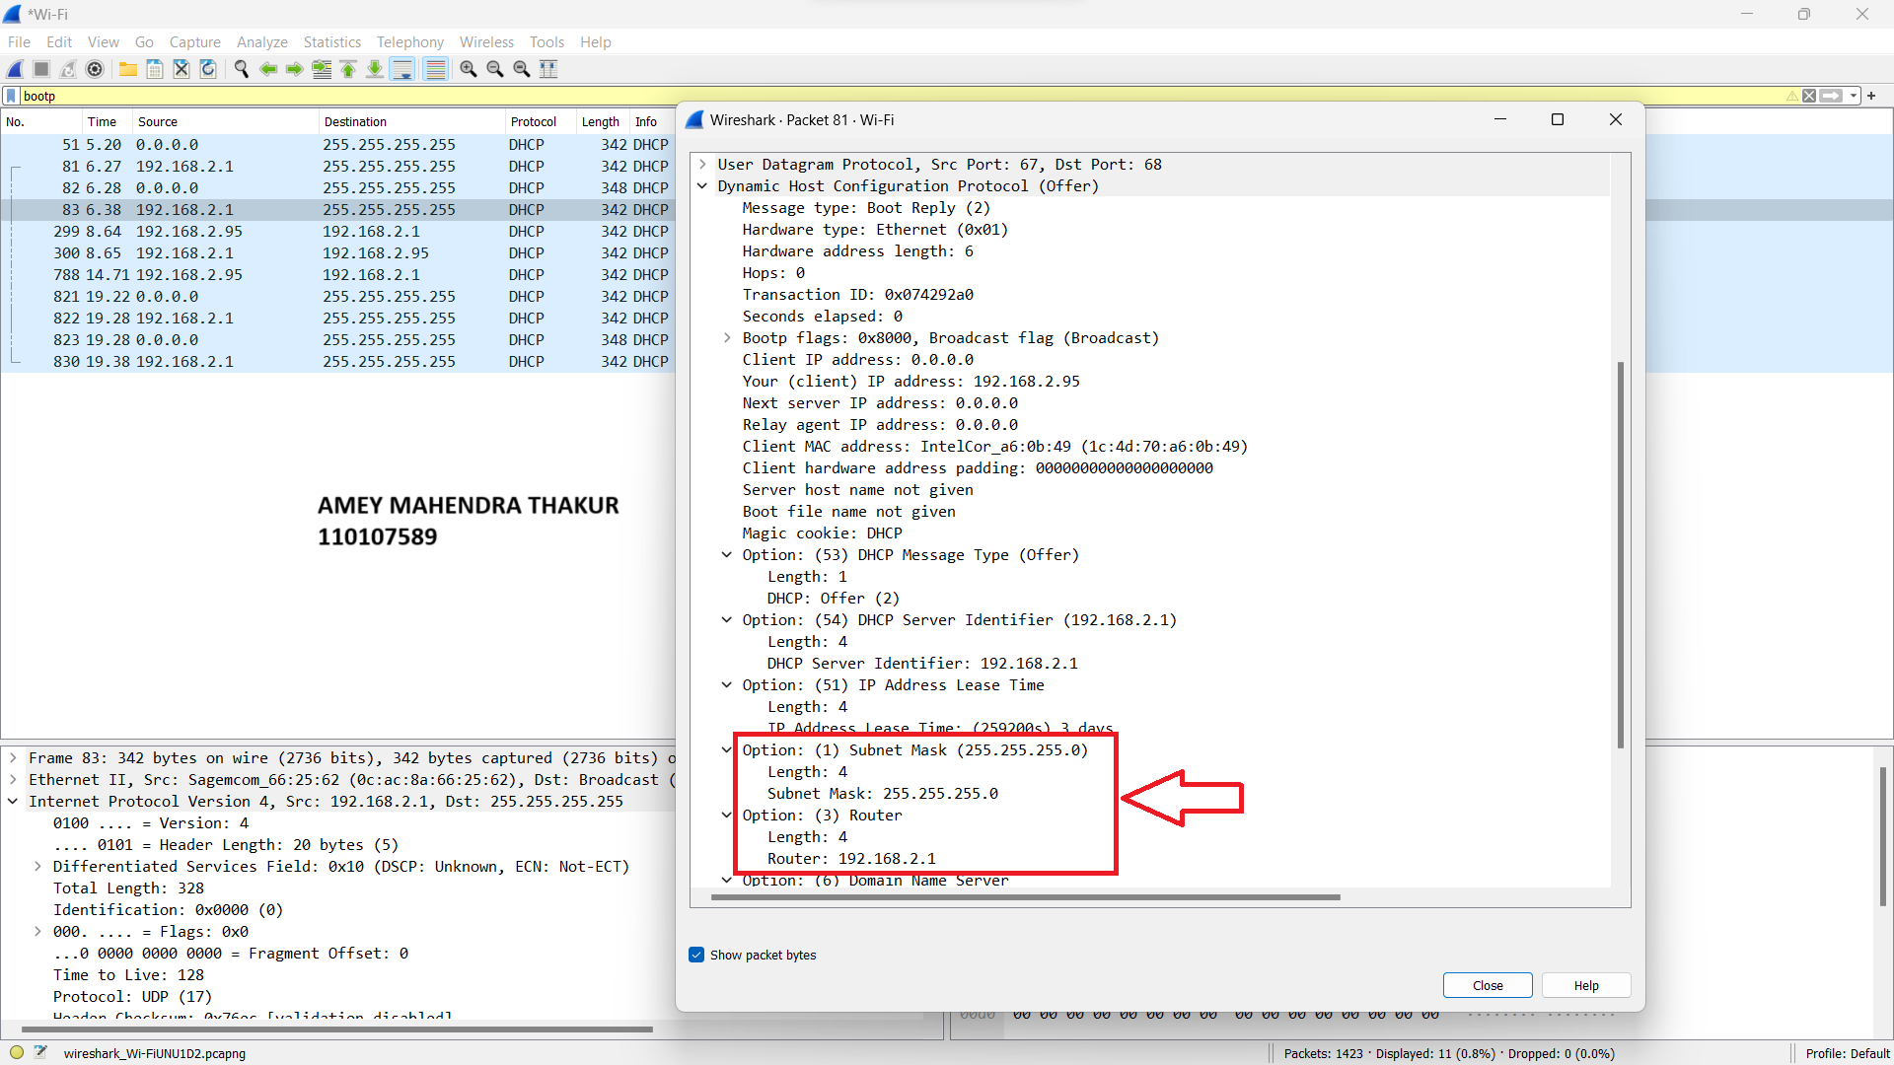

1. In my Wireshark traffic capture, I observed the host formally requesting the IP address that was offered to it, and this IP address is 192.168.2.92.

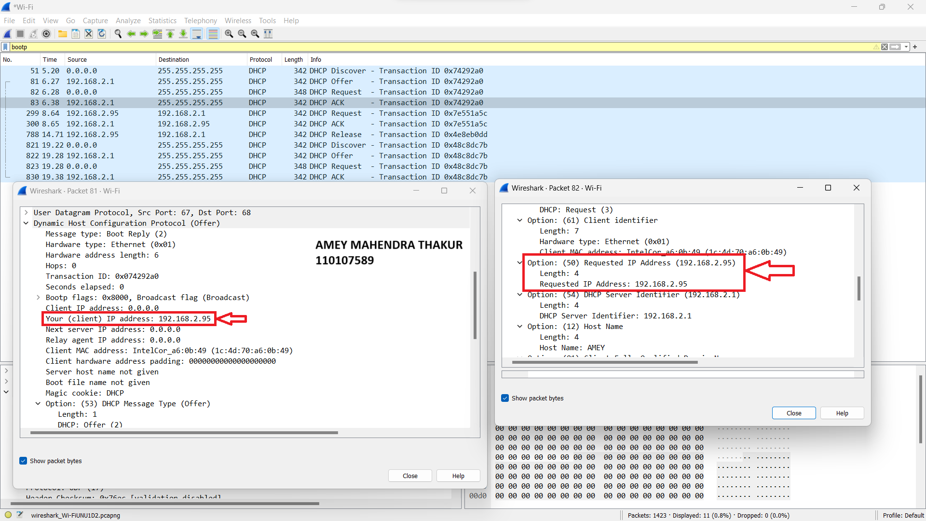

1. The purpose of specifying the lease time in DHCP is to determine the duration for which the DHCP server assigns an IP address to a client. In my specific case, the lease time is set to 259200 seconds, which is approximately equivalent to 3 days.

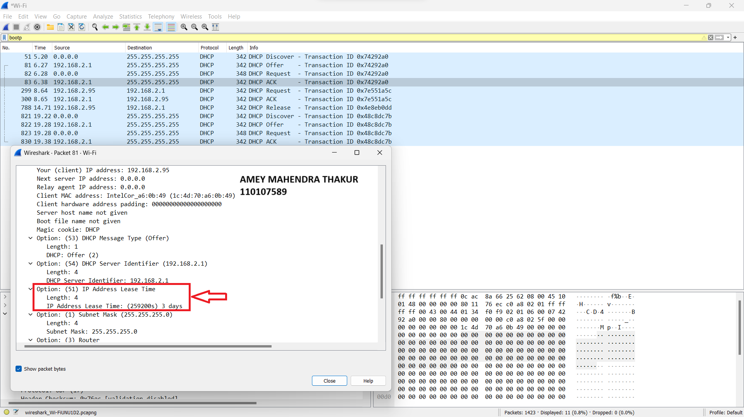

1. The client transmits a DHCP Release message to terminate its lease on the IP address assigned by the DHCP server. It's important to note that the DHCP server doesn't send a response to acknowledge the DHCP Release message from the client. In the event that the DHCP Release message from the client is lost or not received, the DHCP server would need to wait until the lease period for that IP address expires before it can reallocate it to another client.
2. I did not discover any ARP packets occurring between the exchange of DHCP packets.

